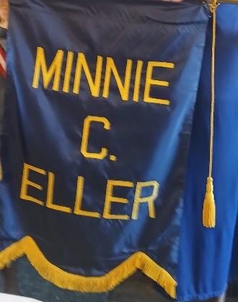

Congratulations Fourth District
Minni C. Eller Banner 2025 Awardee!

The Minnie C. Eller Banner was established by the Virginia Division of the UDC in the 1940’s to recognize District “excellence in all Division activities” and/or the best work meeting the UDC’s five precepts, Historical, Benevolent, Educational, Memorial, and Patriotic.

Minnie Earl Campbell (1871-1952) married Nathan D. Eller and they settled in Lynchburg. She was elected President of the Virginia Division in 1910. The Division had 57 Chapters and over 3200 members at that time. During her tenure she inaugurated Districts within the Virginia Division for better organization of the rapidly growing organization. She also established uniform historical programs and held the first executive board meeting between conventions. Her innovations were adopted by many of the other Divisions. The banner was established in the 1940’s and has been awarded annually since then. This is the highest honor awarded by the Virginia Division.

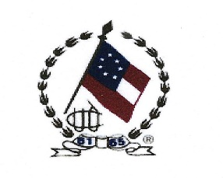
VIRGINIA DIVISION
4th DISTRICT CONFERENCE
April 18, 2026
AGENDA

Registration & Sales 9:00 - 9:55
w/ Assorted Breakfast Pastries & Beverages

(Registration, Materials Pick-up and Sales Tables Open)

Morning Session 10:00 - Noon

Lunch Noon - 1:00

Afternoon Session 1:00 - 3:00

*This is a workshop only meeting*



LUNCHEON MENU

DIY Sandwiches with choice of breads, meats, condiments, salad, brownies and/or cookies

Beverages:
Lemonade, Coffee, Hot Tea, Iced Tea or Water

UDC Credentials Form

(Please indicate all that apply)

__________ Fourth District Member

__________ Chapter President

__________ Member from Other District

__________ Children of Confederacy Member

__________ Associate Member

__________ Guest

__________ Division Officer

__________ District Chairman

__________ Virginia Division Committee
Chairman

__________ General Officer

__________ Past Virginia Division President

__________ Honorary Virginia Division President

__________ Past President General

__________ Honorary President General

Indicate Special Dietary Request:

__________ Vegetarian

__________ Gluten-Free

REGISTRATION FORM
Detach here

Deadline: April 10, 2026
Submit both the Registration Form and UDC Credentials Form

Name:___________________________________

Chapter:_________________________________

Address: _________________________________

__________________________________________

Phone: ___________________________________

Email: ___________________________________

Registration $5.00 ________________

Lunch $40.00 ________________

Sales Table: Whole ($10) ________________

half table ($5) _______________________

Please list chapter or name for table reservation. _______________________________

Total AmountEnclosed: $_______________

Return by deadline with check payable to:
Fairfax Chapter 1410

Mail to:
Charlotte Clinger
4336 Farm House Lane
Fairfax, VA 22032-1614

For questions, contact:
Virginia P. Norton
703.509-6440 or cvnorton@errols.com

DRIVING DIRECTIONS

From the South – I-95 north to I-495 towards Tysons to Route 50 West towards Fairfax. At traffic circle be in the right lane to go around the circle and then go south on Blenhelm Road. The Fairfax Country Club will be on the left.

From the West - I-66 East towards Washington. Take Exit 60 to Rt 123 South towards Fairfax. Turn left (East) on Route 50. Go to the traffic circle and take the first right to Blenhelm Road.

Note: Inside the Club either take the stairs or the elevator to the second floor. The elevator is located on the left of the cross hallway.

LODGING

Best Western Fairfax (closest to meeting location)
3535 Chain Bridge Rd
Fairfax, VA 22030
703.591.5500

Holiday Inn Express Fairfax
10327 Fairfax Blvd
Fairfax, VA 22030
703.359.2888

Residence Inn by Marriott
3665 Chain Bride Road
Fairfax, VA 22030
703.267.2525


Fairfax Chapter 1410
Organized May 21, 1912
is honored to host

The 4TH District
Conference
of the
Virginia Division
United Daughters of the
Confederacy

on
Saturday, April 18, 2026

at the
Fairfax Army Navy Country Club
3315 Blenheim Boulevard
Fairfax, VA 22030

Virginia P. Norton
District 4 Chairman
cvnorton@errols.com

